# Creating Microservices for account and loan.

# Account Microservice Folder

## Structure –

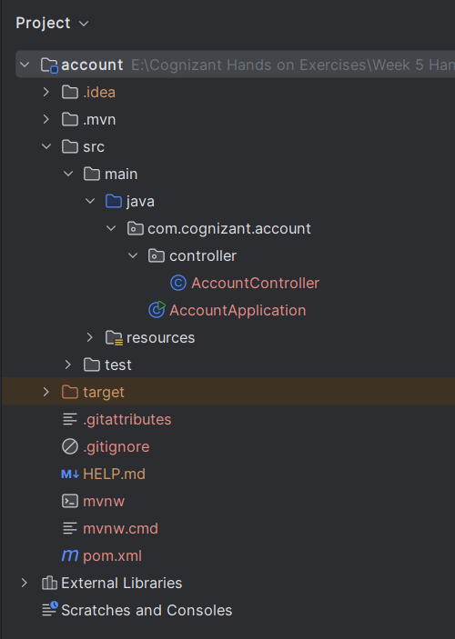

## AccountController.java -

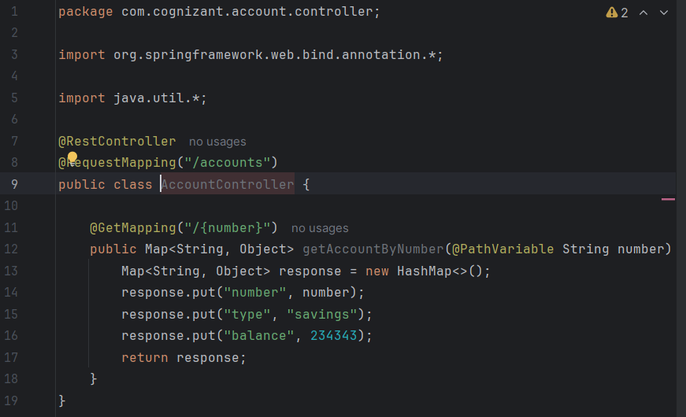

# Output –

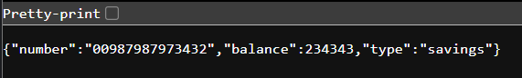

# Loan Microservice Folder –

## Structure –

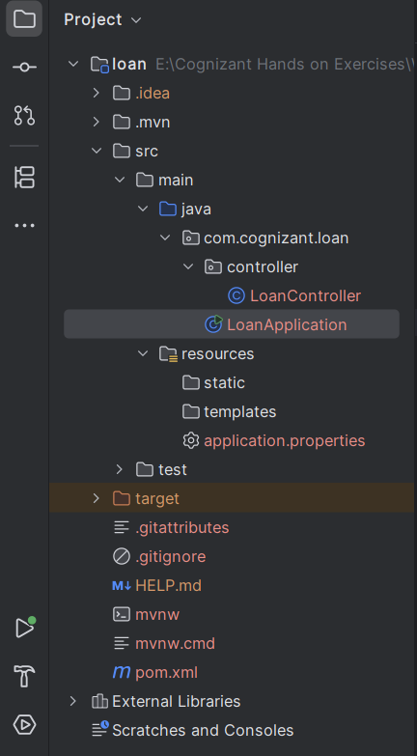

# LoanController.java

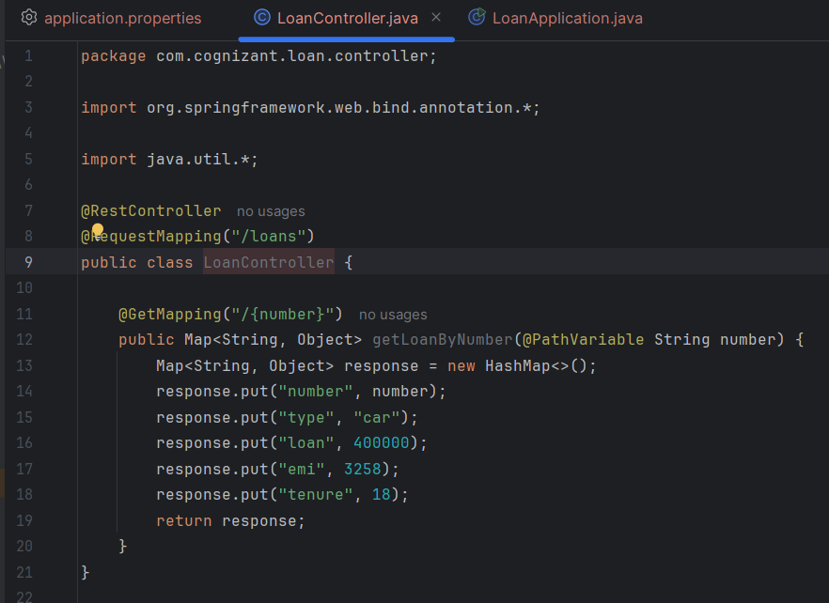

## Application.properties -

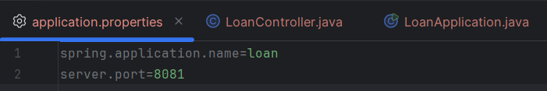

# Output –

